To begin with we have the task at hand:

For the test, I'd just like you to create

a simple website that has a login with a Yoti button at the start.

The website should only request whether the user is 18 or over.

If the condition is met, the website renders the text '18+'.

If the condition is not met, show a generic error saying you

have to be 18 to access the site.

As an extra, think about including a toggle option so that

we can test both cases. i.e. changing the requirement from

Over 18 to Under 18.

In order to complete the task I would break it down into several sections, which each section being reliant on the previous, such that I could work through them and build up the test project.

These tasks are as follows:

Create a simple website that has a login

Add a Yoti button

Website requests whether the user is 18 or over

Website renders a response

(Extra) toggle the requirement (from >18 to <18)

With the tasks laid out I began the first one by taking a basic log-in portal from <https://expressjs.com/en/starter/generator.html> such that I would have a base to build off of.

Then I had to replace jade rendering with ejs rendering as that is more standard across Yoti.

Then I took code from [**https://developers.yoti.com/yoti-app/integration-guide**](https://developers.yoti.com/yoti-app/integration-guide) to get a Yoti button working on the login page.

Then to get the button communicating with Yoti I generated a scenario ID and SKD id/private key from <https://hub.yoti.com/applications/fec85b25-3cb5-4c22-b012-05d5b33a1b09/scenarios> and <https://hub.yoti.com/applications/fec85b25-3cb5-4c22-b012-05d5b33a1b09/keys> respectively

This ended up not working as I could not get the following error to go away:

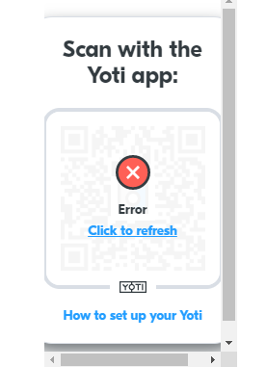

My next idea for solving the task would be to start from the working button in the profile example SDK and work it into a website that fulfilled the tasks.

Essentially this partially reversed the task order I laid out earlier to:

Get Yoti button working

Website requests whether the user is 18 or over

Website renders a response

Create a simple website that has a login

(Extra) toggle the requirement (from >18 to <18)

The one issue I ran into getting the Yoti button working ended up being related to env files.

After that as I had downloaded the correct sample and used the correct scenario in the hub the website/yoti was already requesting whether the user was over 18.

What was harder was rendering the response as with my little experience it took quite a while to get an if statement working on the result given by the request such that the correct responses showed.

Finally did some quick styling for the website.

For the extension I would have to place a toggle switch on the log-in page and have that input toggle an in statement on the results page, toggling the boundary between above and below 18. I may be able to do this with more time to research.

Evaluation:

Whilst I went down several lines in my research for this project that got me nowhere I was eventually able to find something that stuck, and was able to build a test project around it.